Bootcamp Communications Toolkit

As the CTE Makeover Bootcamp kicks off, we encourage you to share your school’s participation through social media, email, and your school’s website, as well as reach out to your local newspapers.

Join the conversation using #CTEMakeover to post your school’s progress on your makerspace design. We’ve included sample messaging below to support your outreach efforts.

Social Media Posts

Twitter & Instagram
Thrilled to design a new #makerspace for our school as part of the #CTEMakeover Bootcamp. ctemakeoverchallenge.com @usedgov

Excited to help our students make more! Stay tuned as we work on a makerspace design for the #CTEMakeover Challenge.

[Snap a picture of your design!] #CTEMakeover Bootcamp is underway, and our #makerspace is in the works!

Facebook
Thrilled to announce that our school is starting the CTE Makeover Challenge Bootcamp to design a new makerspace. We could win a cash prize and the latest maker tech to bring our makerspace to life. Learn more about the Challenge: ctemakeoverchallenge.com

We’re excited to help our students make more. Stay tuned for updates as we work on a makerspace design for the CTE Makeover Challenge.

[Snap a picture of your design!] The CTE Makeover Challenge Bootcamp is underway! Our school’s makerspace design is in the works. Follow along here: ctemakeoverchallenge.com

Email & Web Copy
Please share the following message on the websites and newsletters managed by your school and district:

We’re thrilled to share that our school is competing in the CTE Makeover Challenge to design a new makerspace. Makerspaces provide students the materials and environment they need to create, invent, tinker, and explore, helping them build vital career skills, including critical thinking, planning, communication, and problem solving.

We’re currently participating in a 6-week Bootcamp to finalize our makerspace design plan, budget, and implementation strategy. We could win a cash prize and the latest maker tech (3D printers, yes please!) to bring our makerspace to life. Stay tuned for updates.

Images for Sharing
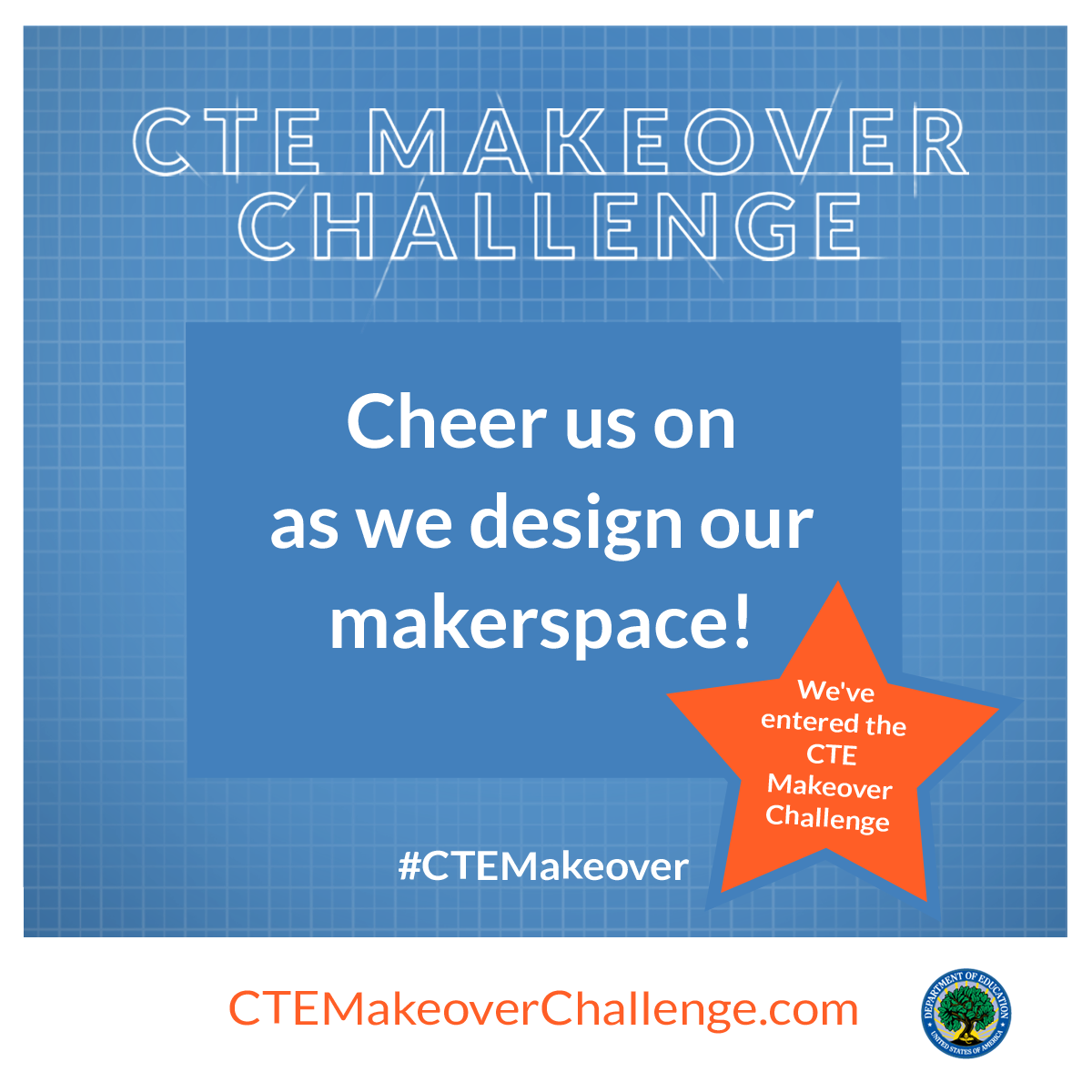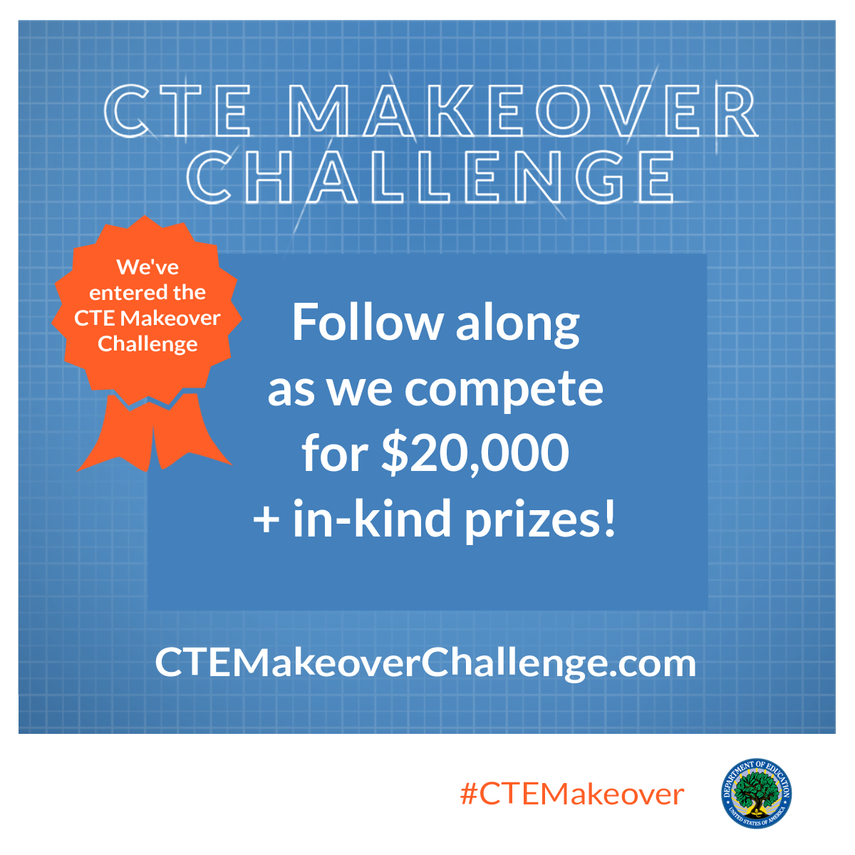

Sample Outreach Message for Press

Hi ________,

Given your coverage of local education initiatives, thought you would be interested that our school has entered the U.S. Department of Education’s CTE Makeover Challenge to design a new makerspace. High schools from all 50 states and Washington, D.C. are competing for $200,000 and in-kind prizes from sponsors, such as LEGO Education, Dremel, Autodesk, Etsy Manufacturing, Snap-on Incorporated, and many more!

I’d be happy to share more information and arrange an interview with our school.

